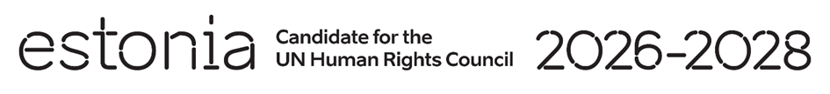

**Universal Periodic Review of North Macedonia**

**2 May 2024**

**Intervention by the delegation of Estonia**

Estonia warmly welcomes the delegation of North Macedonia to its fourth UPR and thanks the delegation for the information provided today.

Estonia acknowledges progress achieved to improve human rights situation, especially the measures taken to combat violence against children. We particularly welcome the ratification of the Council of Europe Convention on preventing and combating violence against women and domestic violence (Istanbul Convention) and all the measures taken so far to implement it. We highlight the further need to ensure its full and effective implementation.

We note, that there are challenges to address the issue of children in street situations and the exploitation of children for begging, as well as to implement the equality and non-discrimination laws and strategy in practice.

We would like to recommend to North Macedonia to:

* strenghten the freedom of opinion and expression and take preventive and protective measures to ensure safety of journalists and media workers, in particular measures to combat online harassment and physical and verbal violence;
* adopt targeted measures to combat school dropout, focusing in particular on measures to retain girls in school;
* develop the national plan for inclusion of comprehensive sexuality education in school curricula;
* take adequate measures to improve the detention conditions and treatment of detained and convicted persons.

Estonia wishes to the delegation of North Macedonia a successful review.

Thank you.