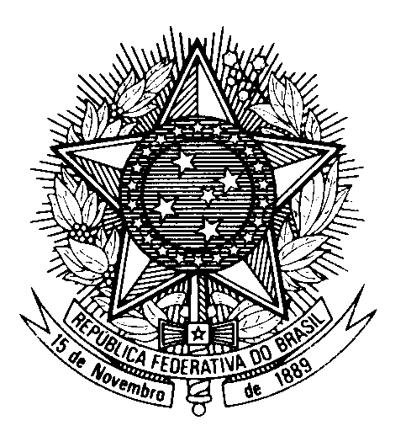

Statement of Brazil in the review of North Macedonia,

during the 46th session of the Working Group on the UPR

(Geneva, 2 May 2024)

Thank you, Mister President.

We commend the implementation of legal reforms to align the country`s legislation with international human rights standards, particularly regarding anti-discrimination, minority rights, judicial independence and gender-based violence.

Brazil also acknowledges the adoption of a new strategy for Roma inclusion, which should include measures to fight hate speech and to end any form of segregation of Roma children in schools.

Brazil recommends North Macedonia to:

1) Redouble efforts and implement public policies to combat peer violence in schools, online bullying and violence against children, including children belonging to ethnic, religious and other minority groups;

2) Adopt legal measeures for the prevention of and protection of persons against discrimination, ensuring their rights on the basis of sex, including the LGBTQIA+ community, and for protection from multiple forms of discrimination.

We encourage North Macedonia to ratify the International Convention on the Protection of the Rights of all Migrant Workers and the International Convention for the Protection of all Persons from Enforced Disappearance.

We also urge North Macedonia to take all necessary measures to ensure the reproductive and health rights and freedoms of women.

We wish North Macedonia success in its review.

Thank you.

