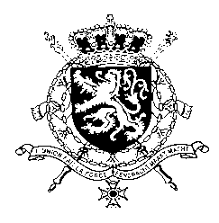
Représentation permanente de la Belgique auprès des Nations Unies et auprès des institutions spécialisées à Genève

WG UPR 46 – Republic of North Macedonia
Belgian intervention
2 May 2024

President,

Belgium welcomes the efforts and positive steps made by the Republic of North Macedonia since its previous UPR. Notwithstanding these efforts, important challenges remain, in particular regarding gender based violence, LGBTQI+ rights and media freedom and the protection of journalists.

Belgium therefore recommends the government of North Macedonia to:

R1. Warrant sufficient funding for the National Action Plan for the implementation of the Istanbul Convention, particularly for activities for the prevention and protection against gender-based violence.

R2. Amend the Criminal Code to incorporate a clear and comprehensive definition of hate speech explicitly including sexual orientation, gender identity, gender expression and sex characteristics as protected grounds and to enhance effective follow-up of complaints involving hate speech and hate crimes based on sexual orientation and gender identity.

R3. Take effective measures to ensure the safety of journalist and media freedom.

Thank you.

