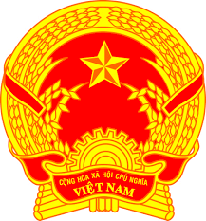
Statement of the Socialist Republic of Viet Nam
46th Session of the UPR Working Group
Review of New Zealand
(Geneva, 29th April 2024)

Mister President,
Viet Nam warmly welcomes the delegation of New Zealand and their national UPR report.
We appreciate policies and programs that New Zealand has implemented in the review period to reduce hatred and discrimination and strengthen social cohesion. We also commend New Zealand’s endeavours to reduce the impact of climate change on human rights, particularly through the introduction of the ‘Zero Carbon’ framework.
In a spirit of constructive dialogue, Viet Nam recommends New Zealand the followings:
First, continue its efforts to mitigate disparities in living standard and access to development outcomes, particularly for vulnerable groups, including people with disabilities, ethnic minorities and children.
Second, further enhance national legislation and mechanism to inclusively prevent and address family and sexual violence.
Viet Nam wishes New Zealand every success in this review.
Thank you, Mister President./.

Word count: 134 (1 min 07 sec/1 min 15 sec)

