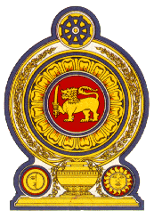

46th Session of the Universal Periodic Review

**Review of New Zealand** – 29th April 2024

Statement by the Democratic Socialist Republic of Sri Lanka

Mr. President,

Sri Lanka commends the national report and presentation of the delegation of New Zealand, providing a comprehensive update on promotion and protection of Human Rights in New Zealand since the last UPR.

The efforts of New Zealand to safeguard the rights of migrant workers and prevent their exploitation such as the Worker Protection (Migrant and Other Employees) Act 2023 and establishment of the Migrant Exploitation Protection Visa are acknowledged.

In a constructive spirit, Sri Lanka recommends that New Zealand;

1. Take all necessary steps to ratify the International Convention for the Protection of All Persons from Enforced Disappearance.
2. Continue with the development and implementation of policies and interventions aimed at effective reduction of inequality in gender pay gaps.
3. Strengthen ongoing efforts in implementing the policies and programmes targeting the low-income households through targeted welfare measures
4. Continue with addressing homelessness with emphasis on urgent housing needs of the vulnerable segments, with the involvement of the concerned communities and stakeholders.
5. Further strengthen the legal framework and interventions to prevent and eliminate domestic and sexual violence against women, including through the early enactment of the proposed legislation to strengthen legal protection for victims of sexual violence and family violence.

We wish New Zealand success in its UPR engagement.