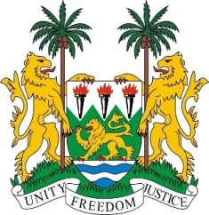

**SIERRA LEONE**

**46th Session of the UPR**

**REVIEW OF NEW ZEALAND**

Monday, 29th APRIL 2024

**Check against delivery.**

**Mr. President**,

Sierra Leone welcomes and thanks **Hon. Paul Goldsmith, Minister of Justice** and the distinguished delegation from New Zealand for the presentation of its national report.

Sierra Leone thanks New Zealand for its annual support to the Office of the High Commissioner for Human Rights. We commend the Government's principled acceptance of all 44 recommendations submitted following the tragic terrorist attacks on two mosques in Christchurch in 2019. Further, we welcome the proactive steps the government has taken to implement these recommendations, including the launch of a comprehensive package of social cohesion tools and resources in 2022.

We also commend the government's efforts to strengthen its climate change regulatory framework, which is critical to addressing the pressing challenges of environmental degradation. In addition, we welcome New Zealand's leadership in promoting gender equality, exemplified by the introduction of legislation to support victims of sexual and domestic violence.

In a spirit of constructive engagement, we recommend the following for New Zealand’s consideration:

1. Consider making early childhood education compulsory for Maori, Pacific and low-income families.
2. Expedite the development of a national framework on business and human rights.
3. Consider developing a national action plan to combat racism.

Sierra Leone wishes New Zealand every success in completing its fourth review cycle.

**Thank you, Mr. President.**