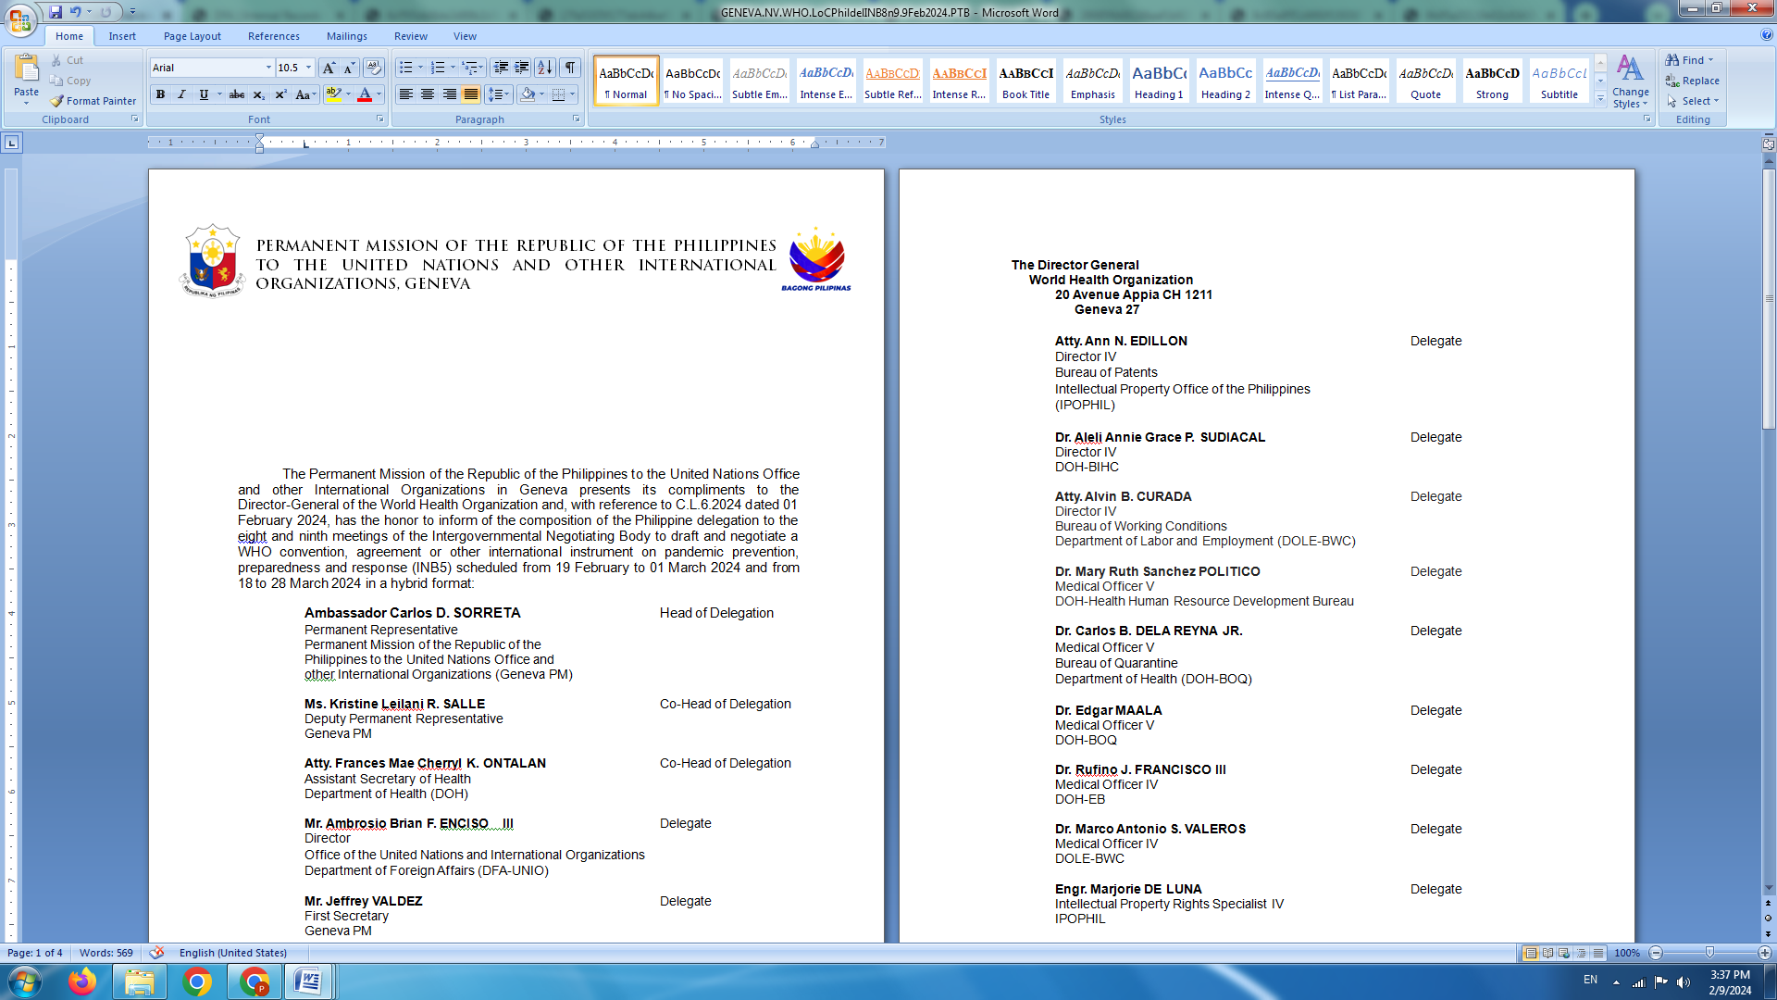

**HUMAN RIGHTS COUNCIL**

**46th Session of the Working Group on the Universal Periodic Review**

30 April 2024, Palais des Nations, Geneva, Switzerland

**UNIVERSAL PERIODIC REVIEW OF NEW ZEALAND**

*To be delivered by:*

**CARLOS D. SORRETA**

**Permanent Representative**

*Speaking time: 1 minute 15 seconds*

The Philippines welcomes the delegation of New Zealand and its updates on the implementation of UPR recommendations from the previous cycle, particularly on the rights of migrant workers, children, and Indigenous Peoples. We note the steps taken to advance these rights and the acknowledgment that more needs to be done.

In the spirit of the friendly relations between our two countries, we recommend that New Zealand:

* Ratify the International Convention on the Protection of the Rights of All Migrant Workers and Members of Their Families;
* Continue to step up efforts to combat trafficking in persons, particularly women and children; and
* Strengthen normative and institutional mechanisms for the protection of the rights of Indigenous Peoples, including by adopting a National Plan Against Racism.

We welcome the focus on human rights and climate change in the report and hopes for New Zealand’s support in multilateral fora for our calls for urgent and scaled up climate action on the basis of justice and equity in line with UNFCCC obligations.

We wish New Zealand a successful review. **END**