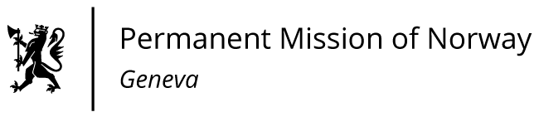

**STATEMENT**

**UPR 46 Session of the Human Rights Council**

**on the human rights situation in New Zealand,**

**as delivered by Mr Tormod C. ENDRESEN**

**Ambassador - Permanent Representative to the UN and other International Organizations.**   
**The Permanent Mission of Norway in Geneva.**

Check against delivery

29 April 2024

President,

Norway welcomes New Zealand’s engagement in the UPR process [and commitment to human rights]. We encourage New Zealand to better protect and promote the rights of indigenous peoples [and strengthen the rights of children].

Norway recommends that New Zealand:

1. Determine and implement, in consultation and agreement with the Māori, the appropriate constitutional processes to recognise, respect, and give effect to the Treaty of Waitangi.

2. Take the appropriate steps to develop a Declaration Plan implementing the UN Declaration on the Rights of Indigenous Peoples.

3. Immediately amend legislation to raise the minimum age of criminal responsibility from 10 years currently, in accordance with international standards.

Thank you.