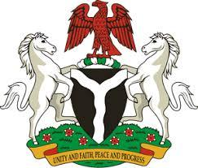

*Please check against delivery*

**HUMAN RIGHTS COUNCIL**

**46TH SESSION OF THE WORKING GROUP OF THE UPR**

**REVIEW OF NEW ZEALAND**

**29TH APRIL, 2024**

**STATEMENT BY NIGERIA**

**Mr. President,**

Nigeria welcomes the delegation of New Zealand to the presentation of its National Report and commends the Government for its commitment to international human rights obligations and human rights mechanisms.

2. Nigeria further commends the Government of New Zealand for its strategy on the settlement and integration of migrants, as well as its measures to prevent exploitation of migrant workers.

3. In the spirit of constructive dialogue, Nigeria wishes to recommend to New Zealand as follows:

1. To deepen commitment to the protection of life, at all stages, by adopting measure that further prioritize the well-being and dignity of every individual, including unborn children;
2. To ensure that relevant laws and polices respect the rights and duties of parents or legal guardians of children, in accordance with international law;
3. To consider further necessary measures to ensure the protection of the rights of migrants and refugees, including through the ratification of the Convention on the Protection of the Rights of all Migrant Workers and Members of their Families; and
4. To redouble efforts to eliminate discrimination and violence against women and girls, including by ensuring their access to single-sex spaces and closing the gender pay gap between men and women.

4. We wish New Zealand a very successful review process.

I thank you, Mr. President.