*Check against delivery*

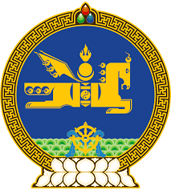

**46th SESSION OF THE UPR WORKING GROUP**

**MONGOLIA’S STATEMENT AT THE REVIEW OF NEW ZEALAND**

**29 April 2024, 09:00 - 12:00 hrs**

(1 min 15 sec)

Thank you, Mr. President.

Mongolia cordially welcomes the delegation of New Zealand to the 4th cycle of UPR and wishes them a productive review.

Mongolia welcomes New Zealand’s ratification of the Optional Protocol to the Convention on the Rights of the Child on a communications procedure and the subsequent work to develop a communications plan to raise awareness of the Convention and its procedure.

In the spirit of constructive dialogue, Mongolia recommends New Zealand to:

**One.** Step up its efforts to raise the minimum age of criminal responsibility to align with international best practice;

**Two.** Promote the acquisition of competencies and skills by young people with disabilities in order to enhance their work opportunities;

**Three.** Accelerate its efforts to develop and adopt a national action plan on business and human rights.

I thank you.

---oOo---