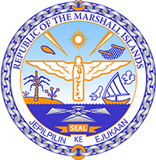

Republic of the Marshall Islands
STATEMENT by H.E Doreen DeBrum
46th Session Universal Periodic Review
29 April – 10 May 2024
Geneva

4th Cycle Review of New Zealand

Thank you, Mr. President.

Kia ora,

The Marshall Islands welcomes the delegation of New Zealand. We commend New Zealand for its efforts to promote and protect indigenous rights, particularly the Government’s commitment to working in partnership with Māori to revitalize the Māori language.

In the spirit of constructive dialogue, we recommend the following:
- Intensify efforts to promote, protect, and revitalize the Māori language.
- Intensify efforts to address the inequities faced by Māori and Pacific peoples.

We wish the delegation every success during its 4th UPR cycle.

Kommol tata and I thank you.

