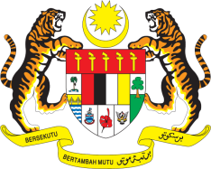

**STATEMENT BY MALAYSIA**

**REVIEW OF NEW ZEALAND**

**46TH SESSION OF THE UPR WORKING GROUP**

**29 APRIL – 10 MAY 2024**

Malaysia thanks New Zealand for the presentation of its national report.

2. We commend New Zealand for conducting constructive engagement and public consultation in the drafting of its national report. We are encouraged by New Zealand’s efforts to address racism and discrimination, protection of migrants, refugees and asylum seekers as well as women, children, persons with disabilities and indigenous peoples.

3. In the spirit of constructive engagement, Malaysia recommends the following:

3.1 First, increase its annual quota for resettlement specifically for Rohingya refugees, including women and girls;

3.2 Second, set a clear timeline in the development of the national plan of action on the United Nations Declaration on the Rights of Indigenous Peoples, and ensure that the national plan is developed in consistent with priorities of Indigenous Peoples.

3.3 Third, redouble efforts to combat all forms of violence against women, including by adopting comprehensive legislation criminalising all forms of gender-based violence and ensuring that all cases of gender-based violence were thoroughly investigated; and

3.4 Fourth, increase climate financing for developing countries and allocate new and additional funding for climate loss and damage.

4. We wish New Zealand a successful review.

Thank you.

**29 APRIL 2024**

**GENEVA**