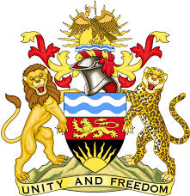

**REPUBLIC OF MALAWI**

**MALAWI STATEMENT ON NEW ZEALAND UNIVERSAL PERIODIC REVIEW**

**MONDAY, 29TH APRIL 2024**

**Mr. President**,

Malawi welcomes New Zealand to this review and thanks the delegation for the comprehensive presentation.

In the spirit of constructive dialogue, Malawi makes the following recommendations:

1. Continue taking all measures to promote and protect the rights of indigenous people.
2. Continue with steps UPR to develop a National Action Plan Against Racism
3. Take all measures to combat sexual violence.

We wish the New Zealand all the best at this review and in the implementation of the recommendations.

**Thank you, Mr. President**.