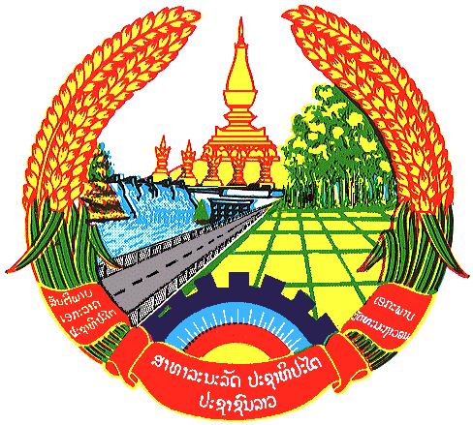

**Statement by the delegation of the Permanent Mission of the Lao PDR to the United Nations Office and other International Organizations in Geneva**

**at the 46th Session of UPR Working Group**

**Geneva, 29 April 2024**

(Speaking time 1.15 minute)

Review of New Zealand (09:00 - 12:30)

1. Thank you, Mr. President, for the floor.
2. My delegation warmly welcomes the delegation of New Zealand and thanks for the presentation of the national report.
3. The Lao PDR commends New Zealand for the progress made in improving its legal and institutional frameworks for human rights, including the establishment of the Ministry of Disabled People devoted to promote and protect the rights of persons with disabilities. We also welcome its contribution to the international development cooperation.
4. The Lao PDR would like to make the following recommendations:

* Continue to strengthen the rights of women, especially their representation in leadership for both public and private sectors; and
* Redouble its efforts to implement the national plan of action against human trafficking.

1. We wish New Zealand every success in this UPR cycle review.
2. I thank you, Mr. President.