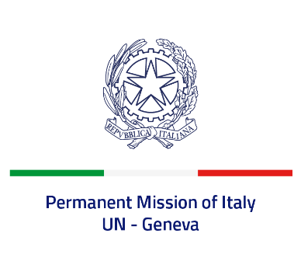

*Check against delivery*

**UPR 46 - New Zealand**

**Monday 29 April 2024, 9:00 - 12:30**

**Delivered by: Minister Stefano Pisotti, Deputy Permanent Representative of Italy**

Thank you, Mister President.

We thank the distinguished delegation of New Zealand for the presentation.

Italy commends New Zealand for the establishment of the Ministry for Disability in 2022 aimed at progressing work to transform the disability support system.

We also welcome the entry into force of the Optional Protocol to the Convention on the Rights of the Child on a communications procedure.

Italy seizes this opportunity to offer New Zealand the following recommendations:

* *Further promote the inclusion of Māori in decision-making processes, as well as their access to resources and services, and address their overrepresentation across the criminal justice system;*
* *Redouble its efforts to end all forms of discrimination and violence against women, especially domestic and sexual violence;*
* *Expedite its consideration of acceding to the International Convention for the Protection of All Persons from Enforced Disappearance.*

We wish New Zealand a successful review.

I thank you.