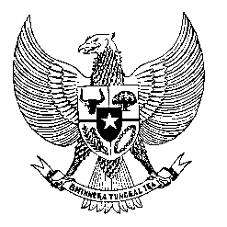

Permanent Mission
of the Republic of Indonesia to the UN, WTO,
and Other International Organizations
in Geneva

STATEMENT BY THE DELEGATION OF THE REPUBLIC OF INDONESIA
AT THE 46th SESSION OF THE UPR WORKING GROUP
CONSIDERATION OF THE UPR REPORT OF NEW ZEALAND
29 APRIL 2024

Mr. President,

Indonesia welcomes the esteemed delegation of New Zealand, led by H.E. Paul Goldsmith, the Minister of Justice.

We appreciate New Zealand’s efforts in providing childcare assistance benefiting hundreds of thousands of families.

In the spirit of constructive cooperation, Indonesia offers the following recommendations:

- Uphold, respect, and advance New Zealand’s human rights obligations for the Māori in accordance with Te Tiriti o Waitangi…

- including by incorporating Te Tiriti o Waitangi into key legislations to ensure enforceability of Te Tiriti…

- and ensuring the implementation of recommendations from the Waitangi Tribunal.

- Take further steps to enhance access to public housing, especially for vulnerable groups of people.

- Persist in implementing all recommendations pertaining to hate crimes and hate speech outlined by the Royal Commission of Inquiry into the terrorist attack on the Christchurch Mosques.

- Ensure protection from violence and abuse for persons with disabilities, especially women and children, particularly in institutional care facilities.

We wish New Zealand for a successful review.

Thank you.

167 words/1 minute and 15 seconds

