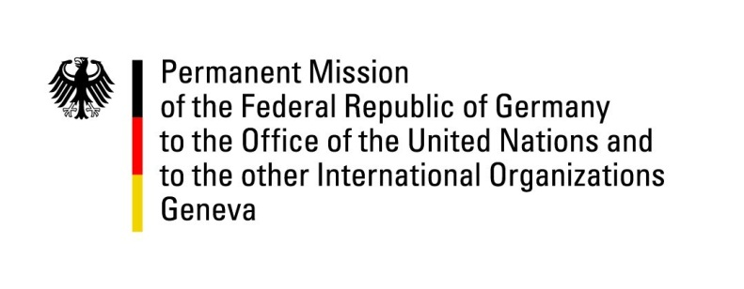

**United Nations Human Rights Council**

**46th Session of the UPR Working Group**

**Geneva, April 29th, 2024**

**German Recommendations and advance questions to**

**New Zealand**

Mister President,

Germany welcomes the delegation of New Zealand and commends the country for its outstanding commitment to the promotion and protection of human rights.

Germany welcomes the adoption of the National Strategy and Action Plan addressing family and sexual violence and the establishment of a special minister for the elimination of family violence and sexual violence. However, we are concerned about the potential impact of austerity measures on the realization of all human rights, especially for members of disadvantaged communities.

Germany recommends New Zealand to

1. improve the level of human rights protection by raising human rights and the Treaty of Waitangi to supreme law and incorporate them into a written constitution;
2. amend the New Zealand Bill of Rights Act to incorporate civil, political, economic, social and cultural rights, as set out in the international covenants;
3. raise the minimum age of criminal responsibility to 14 years to align with international human rights standards; to consider repealing the practice of remanding children into police custody and to reduce the proportion of children in secure youth justice residence who are on remand;
4. introduce pay transparency legislation with a view to pay secrecy, pay gaps, and initiatives to eliminate pay inequity on the basis of ethnicity, disability and gender.

Thank you, Mister President.