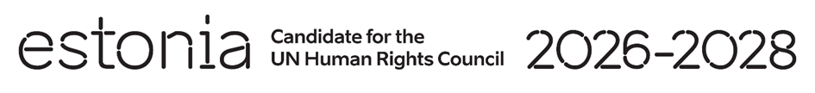

**Universal Periodic Review of New Zealand**

**29 April 2024**

**Intervention by the delegation of Estonia**

Estonia welcomes the delegation of New Zealand to its fourth UPR and thanks the delegation for the information provided today.

We are pleased that many positive steps have been taken since the last review. Estonia commends New Zealand for the ratification of the Optional Protocol to the Convention on the Rights of the Child on a communications procedure and for the adoption of the Abortion Legislation Act. We recognize the efforts to enhance the protection of the rights of children, including steps taken to reduce child poverty.

Estonia would like to recommend to New Zealand:

* combat all forms of violence against women, including by adopting comprehensive legislation criminalizing all forms of gender-based violence;
* improve access to sexual and reproductive health services;
* ensure that Indigenous Peoples are productively involved in decision making on issues impacting them.

Estonia wishes to the delegation of New Zealand a successful review.

Thank you.