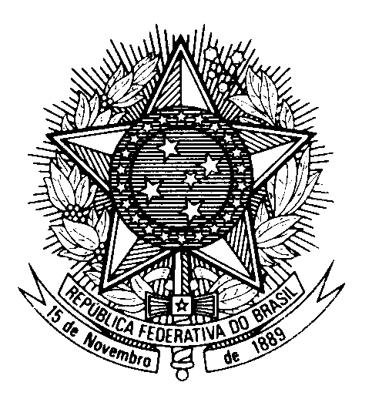

Statement by the Permanent Mission of Brazil to the United Nations Office in the review of New Zeland during the 46th session of the Working Group on the Universal Periodic Review

(Geneva, 29 April 2024)

Mr. President,
Brazil welcomes the delegation of New Zealand.

Brazil acknowledges New Zealand`s commitment to tackle domestic and sexual violence. Its inclusive policies, spanning various levels and reaching remote communities and migrant families, contribute to safeguarding the human rights of women and girls.

Brazil also appreciates New Zealand´s ratification of the Optional Protocol on a Communications Procedure under the CRC.

In line with our recommendation in the last UPR, we would like to encourage the country to promote equal access to mental health and wellbeing support, particularly, to maori, pasifika and young people.

In a spirit of constructive engagement, Brazil recommends New Zealand:

1) to incorporate the rights recognized by the Treaty of Waitangi into New Zealand's legal framework, and to provide constitutional protection to indigenous peoples´ rights;

2) to continue its efforts to modernize legislation to protect migrant workers, specifically targeting prevention of trafficking in persons and modern slavery, ensuring fair treatment and upholding their rights.

I thank you.

(160 words)

