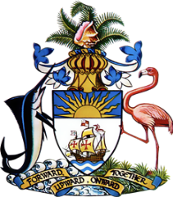

**Statement by  
 Permanent Mission of The Bahamas to the United Nations Office and other International Organizations in Geneva**

**at the 46th Session of the Universal Periodic Review Working Group**

***Presentation of UPR Report by New Zealand* 29April 2024**

Thank you, Mr. President,

The Bahamas thanks New Zealand for presenting its comprehensive report and commends the progress made since the last review.

We commend New Zealand's dedication to human rights, highlighted by its strong adherence to international treaties, efforts to combat trafficking and protecting the rights of children, women, and persons with disabilities (PWDs). These actions affirm its commitment to promoting good human rights practices within both the Commonwealth and the international community at large.

In a constructive spirit, The Bahamas recommends that New Zealand,

1. Build on efforts to protect the rights of indigenous populations, particularly the Māori, by enhancing their involvement in decision-making processes and further addressing disparities in health, education, and employment.
2. Review and enhance the Child and Youth Well-being Strategy to ensure it effectively addresses the diverse needs of young New Zealanders, particularly in mental health, education, and protection from abuse and neglect.
3. Strengthen mechanisms to combat family and sexual violence through increased support services for victims and national awareness campaigns aimed at preventing violence and supporting healthy relationships.

We extend our best wishes to New Zealand for a successful review.

I thank you.