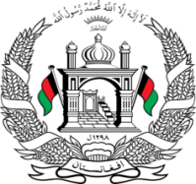

**Permanent Mission of Islamic Republic of Afghanistan**

**Session of the UPR Working Group**

**Statement on the Review of New Zeeland**

29th April 2023 at 09:00.

**Mr./Mme. (Vice) President,**

Afghanistan cordially welcomes the delegation of New Zeeland. We commend the positive and significant developments since the 3rd cycle in the continue efforts to combat violence against women and to increase women’s representation in leadership roles in the public sector.

**Mr./Mme. (Vice) President,**

In the spirit of constructive engagement, we wish to make the following recommendations:

1. Ensure that any engagement with the *de facto* authorities is contingent on and centered around their respect for the human rights and fundamental freedoms of the people of Afghanistan, especially those of women, children, persons with disabilities, and minorities.
2. Ratify the International Convention on the Protection of the Rights of All Migrant Workers and Members of Their Families.

Finally, Afghanistan wishes New Zealand every success in the review process.

**I thank you, Mr./Mme. (Vice) President.**