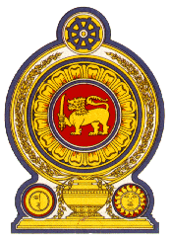

46th Session of the Universal Periodic Review

**Review of Eritrea**– 6th May 2024

Statement by the Democratic Socialist Republic of Sri Lanka

Mr. President,

Sri Lanka warmly welcomes the delegation of Eritrea and appreciates the presentation made.

Sri Lanka commends the measures taken by Eritrea to invest in the Public Health System in conjunction with other development endeavors which has resulted in continuous improvements of health impacted indicators including under-five mortality rate, maternal mortality ratio and life expectancy since its last UPR.

In a constructive spirit, Sri Lanka recommends that Eritrea;

1. Continues to enhance the quality of education for all school age children including providing continuous pre-service and in-service trainings to upgrade the professional competency of teachers and school administrators.
2. Strengthens efforts to ensure food and nutrition security and access to food and to secure the growth of agriculture to cope with climate change and to guarantee the availability of affordable and nutritious food throughout the country.
3. Improve the employability of women in the formal sector and ensure the establishment of a social security system for vulnerable women.
4. Take steps to adopt a legislative framework on sexual harassment and ensure that victims have access to effective complaints procedures and remedies

We wish Eritrea success in its UPR engagement.