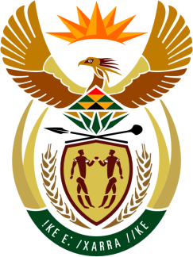

**SOUTH AFRICAN PERMANENT MISSION**

**TO THE UNITED NATIONS**

**AND OTHER INTERNATIONAL ORGANISATIONS**

**46th SESSION OF THE WORKING GROUP ON THE**

**UNIVERSAL PERIODIC REVIEW**

**Review of ERITREA**

**06 MAY 2024**

**(70 Sec)**

**speaker no: 34**

***Check against delivery***

Mr. President,

South Africa welcomes the distinguished delegation of Eritrea to this UPR Session and wishes the country a successful review.

South Africa acknowledges Eritrea’s efforts to align the country’s health policy with the 2030 Sustainable Development Goals, as reflected in the review undertaken towards its Health Sector Strategic Development Plan. While challenges remain, these efforts, coupled with investment in the public health system have no doubt contributed to an improvement in the country’s infant and maternal mortality rates as well as life expectancy.

South Africa wishes to respectfully recommend that Eritrea:

* Continue to bolster its cooperation with the Office of the High Commissioner for Human Rights;
* Continue to strengthen measures to improve the conditions of prisoners in accordance with the Nelson Mandela Rules;
* Ensure the effective implementation of articles 581 and 607 of its Transitional Civil Code and continue to address the root causes of child marriage; and
* Consider the development of a specific regulatory framework addressing the rights of women and the adoption of a comprehensive strategy to eliminate discriminatory stereotypes and harmful practices against women and girls.

I thank you.