Jamhuuriyadda Federaalka Soomaaliya  Ergada Joogtada Soomaliyeed ee Qaramada Midoobey ee Geneva, Switzerland. | 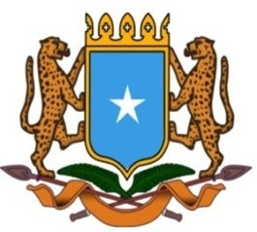 | جمهورية الصوما ل الفيدرالية  البعثة الدائمة لجمهورية الصومال بمكتب الأمم المتحدة بجنيف وبالوكالات المتخصصة بسويسرا

Permanent Mission of the Federal Republic of Somalia to the United Nations Office at Geneva and other International Organizations in Switzerland

Check Against Delivery
Statement by the Delegations of Somalia,
Salah Abubakar, Second Councillor and Charge D’Affaires.a.i
at the Review of Eritrea, during the 46th Session of the UPR Working Group on Monday, May 6, 2024 from 14:30 to 18:00, in the Room XX of the Palais des Nations in Geneva.

Thank you Mr. President,

Somalia warmly welcomes the delegation of the Republic of Eritrea to this UPR working group session and thanks them for their comprehensive national report.

Somalia recommends the following:

First, continue to strengthen the cooperation with the Office of the United Nations High Commissioner for Human Rights.

Second, to promote Human Rights infrastructure and its national Institutions.

Finally, to eliminate all forms of discriminations against ethnic minorities and promote fair and equal treatment in the society and the law.

Somalia wishes the delegation of Eritrea a successful outcome in this review.

I Thank you Mr. President.

