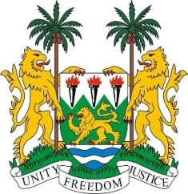

**SIERRA LEONE**

**46th Session of the UPR Statement**

**The State of Eritrea**

Monday, 6 May, 2024

Sierra Leone welcome the Permanent Mission of Eritrea, and thanks it for the presentation of its national report.

We commend the State of Eritrea for providing free education, including boarding facilities, which is a significant step towards ensuring equitable access to education. In addition, initiatives to increase the participation, retention and academic achievement of school-age children are essential to fostering a knowledgeable and empowered society.

The government's efforts to build school facilities in rural areas of Eritrea are commendable, as they provide access to education for children from underprivileged families and hard-to-reach areas. We also welcome initiatives to expand non-formal education through technical and vocational training, which has led to a significant increase in the literacy rate from 85% to 100%.

We welcome the promulgation of Proclamation No. 184/2023, which aims to improve access to and expedite the administration of justice in Eritrea. These developments reflect the Government's commitment to promoting human rights, social welfare, and overall development in the country.

In the spirit of promoting constructive dialogue, Sierra Leone offers the following recommendations

1.    Maintain and strengthen efforts to promote regional peace and security, with a particular focus on the Horn of Africa.

2.    Explore the establishment of a public defender's office to provide pro bono legal services, particularly to juveniles and persons who cannot afford legal representation.

3.    Maintain full cooperation with the Human Rights Council and its mechanisms, demonstrating commitment to upholding human rights standards and fulfilling international obligations.

Sierra Leone extends its best wishes to Eritrea for a successful fourth cycle review.

**Thank you, Mr President**