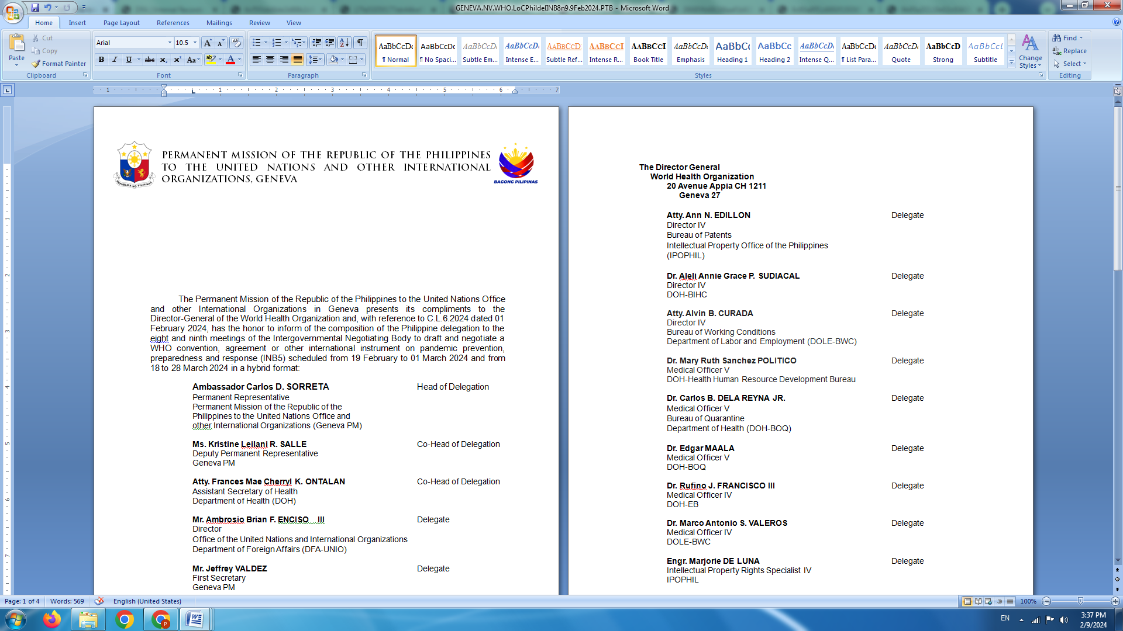

**P H I L I P P I N E S**

**HUMAN RIGHTS COUNCIL**

**46th Session of the Working Group on the Universal Periodic Review**

30 April 2024, Palais des Nations, Geneva, Switzerland

**UNIVERSAL PERIODIC REVIEW OF ERITREA**

*To be delivered by*

**Mr. Neil C. Brillantes**

*Speaking time: 1 minute 10 seconds*

The Philippines welcomes the delegation of Eritrea and the presentation of its national report.

We acknowledge the efforts made during the review period to improve the delivery of public health services, including those aimed at reducing maternal and infant mortality.

We also note the steps taken to enhance access to education, particularly the campaign to increase the enrolment of school age girls in rural areas.

In a constructive spirit, we recommend the following to Eritrea:

1. Continue to strengthen mechanisms to effectively protect the rights of the child, including against female genital mutilation and child, early and forced marriage;
2. Redouble efforts to promote gender equality, women empowerment and the elimination of discrimination and all of forms of violence against women and girls; and
3. Continue to build a national legal system that is aligned with its international human rights obligations.

My delegation wishes the people and Government of Eritrea all success in their continuing journey towards durable peace and inclusive development. Thank you. **END.**