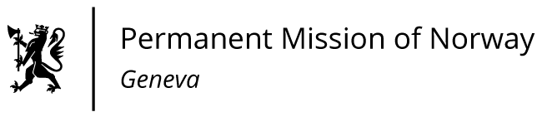

**STATEMENT**

**UPR 46 Session of the Human Rights Council**

**on the human rights situation in Eritrea,**

**as delivered by Ms Jannicke GRAATRUD**

**Minister, Deputy Permanent Representative to the UN and other International Organizations.**   
**The Permanent Mission of Norway in Geneva.**

Check against delivery

6 May 2024  
  
President,

Norway welcomes the participation of Eritrea in the UPR process but remain deeply concerned about the human rights situation.

Norway recommends that Eritrea:

1. Protects the right to freedom of expression, association, and peaceful assembly.
2. Ends practices of arbitrary arrests, indefinite detention, torture and ill-treatment of detainees and releases human rights defenders and political prisoners, including journalists and members of religious groups held on account of their beliefs or affiliations.
3. Takes concrete measures to fight sexual and gender-based violence against women and girls, including female genital mutilation and child marriages.
4. Fully cooperates with the Office of the High Commissioner for Human Rights and give access to the UN special procedures mandate holders to verify, report and advice on the human rights situation.   
   Thank you.