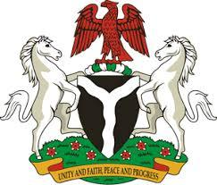

*Please check against delivery*

**HUMAN RIGHTS COUNCIL**

**45TH SESSION OF THE WORKING GROUP OF THE UPR**

**REVIEW OF ERITREA**

**6TH MAY, 2024**

**STATEMENT BY NIGERIA**

**Mr. President,**

Nigeria warmly welcomes the delegation of the brotherly nation of Eritrea to the presentation of its National Report. We commend the Government for its cooperation with human rights mechanisms and dedication to implementing previous recommendations.

2. Nigeria acknowledges the commitment of Eritrea to upholding human rights and urges continued efforts to ensure the full realization of human rights for its citizens. We commend Eritrea for its initiatives in healthcare, education and infrastructure development and recognize these efforts as vital to enhancing the socio-economic well-being of its people.

3. While acknowledging the efforts and commitments of the Government of Eritrea to promote and protect human rights, Nigeria recommends the following:

1. To intensify efforts to mobilise resources and seek necessary international support to improve the socio-economic development of its people; and
2. To implement and strengthen comprehensive legal reforms to improve access to justice for all citizens and ensure fairness and efficiency of the system .

4. We wish Eritrea a very successful review process.

**I thank you, Mr. President**.