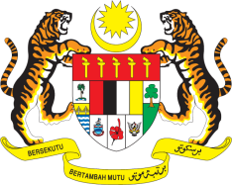

**STATEMENT BY MALAYSIA**

**REVIEW OF ERITREA**

**46TH SESSION OF THE UPR WORKING GROUP**

**29 APRIL – 10 MAY 2024**

Malaysia thanks Eritrea for the presentation of its national report.

1. Malaysia commends Eritrea for its significant strides in promoting human rights in the area of healthcare and education. Malaysia is also encouraged by Eritrea’s policy on women empowerment through the National Union of Eritrean Women (NUEW) and legal measures against discriminatory practices. While these positive developments are noteworthy, continued attention to the full implementation of previous UPR recommendations and the resolution of significant ongoing human rights challenges remain vital.
2. In the spirit of constructive engagement, Malaysia recommends the following:
   1. First, strengthen measures to promote women’s participation in political and economic spheres by removing systemic barriers and providing targeted support for women's leadership development;
   2. Second, continue efforts to enhance the quality of the educational system and infrastructure for all, especially children with disabilities and those living in remote and rural areas; and
   3. Third, strengthen efforts to improve healthcare infrastructure, particularly in rural areas.
3. We wish Eritrea a successful review.

Thank you.

**6 MAY 2024**

**GENEVA**