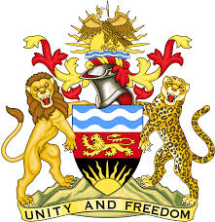

**REPUBLIC OF MALAWI**

**MALAWI STATEMENT ON ERITREA UNIVERSAL PERIODIC REVIEW**

**MONDAY, 6TH MAY 2024**

**Mr. President**,

Malawi welcomes the Republic of Eritrea to this review and thanks the delegation for the comprehensive presentation. Malawi is honoured to be part of the Troika to Eritrea’s review.

Malawi commends Eritrea’s efforts towards the implementation of the recommendations made in the previous UPR cycle which include; improving access to education especially in rural and remote areas, the development of the 2022-2026 National Social Protection Policy and National Social Protection Strategic Plan aimed at addressing socio-political drivers that perpetuate socio-economic needs and identifying persons with special needs, including persons living with disabilities and children.

In the spirit of constructive dialogue, Malawi makes the following recommendations to Eritrea:

1. Ratify the Convention on the Rights of Persons with Disabilities.
2. Ratify the International Convention for the Protection of All Persons from Enforced Disappearance.
3. Address intersecting forms of discrimination against women and girls with disabilities and ensure their inclusion and enjoyment of all rights under the Convention on the Elimination of All Forms of Discrimination against Women.

We wish Eritrea all the best at this review and in the implementation of the recommendations.

**Thank you, Mr. President**.