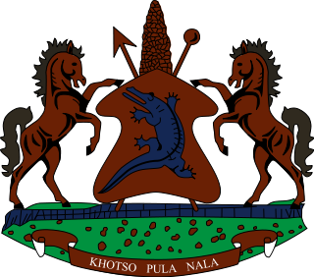

**INTERVENTION OF THE DELEGATION OF LESOTHO UNDER THE UPR REVIEW OF ERITREA**

**06 MAY 2024**

**GENEVA, SWITZERLAND**

**Thank you Mr. President,**

Lesotho welcomes the delegation of Eritrea and thank them for the presentation of their National Report on the actions made to improve the situation of human rights of human rights in the country. We recognise the various steps undertaken by the Government to improve the highest attainable standard of health. We applaud Eritrea for improving access to quality education, particularly for vulnerable groups and persons living in remote areas.

Whilst recognising the positive developments made, Lesotho seizes this opportunity to offer the following recommendations to the Government of Eritrea; 1. To ratify the Convention against Discrimination in Education; 2. To extent standing invitations to the special mandate holders and special procedures of the office of the High Commissioner for Human Rights and, lastly, to bolster efforts to ensure effective engagement with treaty bodies by preparing state party reports on human rights treaties, ratified by the Government.

We wish to conclude by wishing the Government of Eritrea a successful review.

**THANK YOU**