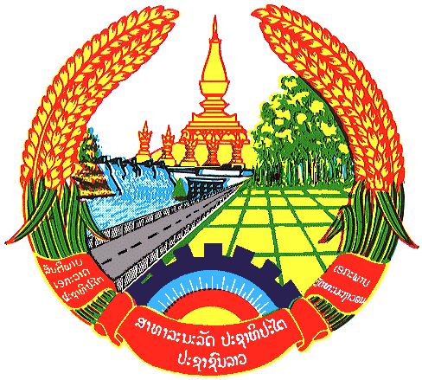

**Statement by the delegation of the Permanent Mission of the Lao PDR to the United Nations Office and other International Organizations in Geneva**

**at the 46th Session of UPR Working Group**

**Geneva, 6 May 2024**

(Speaking time 1.10 minute)

Review of Eritrea (14:30 – 18:00)

1. Thank you, Mr. President.
2. My delegation warmly welcomes the delegation of Eritrea and thanks for the presentation of the national report.
3. The Lao PDR takes note the progress made by Eritrea in the implementation of the accepted UPR recommendations received from the previous cycle, especially the right to health, education and the rights of vulnerable groups, including women, children and persons with disabilities.
4. In this constructive spirit, the Lao PDR recommends Eritrea the followings:

**ONE:** Strengthen the implementation of national mechanisms to promote women’s rights and the empowerment of women; and

**TWO:** Continue efforts to improve the right to education, especially strengthening access to education for girls and persons living in remote area.

1. We wish Eritrea a successful UPR review.
2. I thank you, Mr. President.