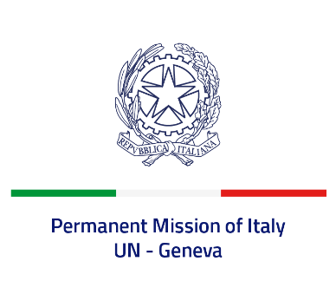

*Check against delivery*

**UPR 46 - Eritrea**

**Monday 6 May 2024, 14:30 - 18:00**

**Delivered by: Ambassador Vincenzo Grassi, Permanent Representative of Italy**

Thank you, Mister President.

We thank the distinguished delegation of Eritrea for the presentation.

Italy recognizes Eritrea’s commitment to combat female genital mutilation and other forms of gender-based violence, including through awareness-raising activities and a national mechanism aimed at strengthening the community-based child protection systems.

Italy seizes this opportunity to offer Eritrea the following recommendations:

·        *Limit the duration of compulsory national service to 18 months, in accordance with international standards, and ensure strict compliance with the minimum age of 18 years old for recruitment;*

·        *Withdraw the reservations made to the UN Convention Against Torture and consider acceding to its Optional Protocol;*

·        *Ensure the full enjoyment of the right to freedom of religion or belief and guarantee the freedoms of opinion and expression;*

·        *Continue the efforts to eradicate female genital mutilation and child, early and forced marriage.*

We wish Eritrea a successful review.

I thank you.