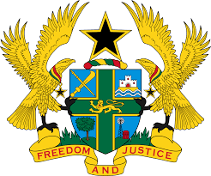

**STATEMENT DELIVERED BY GHANA DURING THE 46TH SESSION**

**OF THE UPR WORKING GROUP, ON MONDAY 6TH MAY, 2024**

**UNIVERSAL PERIODIC REVIEW OF ERITREA**

Mr. Vice President,

We warmly welcome the delegation of Eritrea.

2. We applaud the commendable efforts made by Eritrea to improve access to healthcare for all segments of the population, particularly for vulnerable groups and persons living in remote areas and the measures adopted to enhance educational outcomes for children.

3. We further commend the commitment of the Government of Eritrea to food security, especially the sustainable agricultural programmes it is implementing to ensure the availability of affordable and nutritious food all year round.

4. In the spirit of constructive dialogue, Ghana recommends the following:

1. **Accede to the Optional Protocol to the Convention against Torture and Other Cruel, Inhuman or Degrading Treatment or Punishment;**
2. **Adopt measures to prevent and combat terrorism, and ensure that these measures are fully compatible with its obligations under the International Covenant on Civil and Political Rights; and**
3. **Accelerate reforms of its national legal framework to enhance its compliance with the provisions of international and regional human rights instruments.**

5. Ghana wishes Eritrea success in the review process.

I thank you.