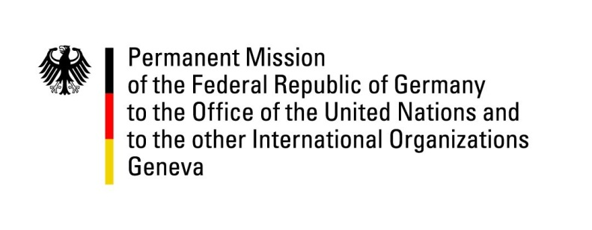

**United Nations Human Rights Council**

**46th Session of the UPR Working Group**

**Geneva, May 6, 2024**

**German Recommendations to**

**Eritrea**

Mister President,

Germany welcomes the delegation of Eritrea and commends the country for efforts to improve access to health care and education across the country.

However, Germany remains gravely concerned by the overall human rights situation in the country and the lack of improvement especially with regards to civil and political freedoms, the excessive and arbitrary nature of the national service, and the situation of people in detention.

Germany therefore recommends Eritrea to

* End the practice of unlimited national service and establish provisions for conscientious objection to military service;
* Ratify the Second Optional Protocol to the International Covenant on Civil and Political Rights;
* Fully implement the Convention against Torture and Other Cruel, Inhuman or Degrading Treatment or Punishment, and improve the conditions of persons in detention;
* Release persons detained for political reasons, and refrain from restricting the freedoms of expression, peaceful assembly and association, as well as the freedom of religion or belief;
* Continue efforts to remove gender disparity in education and promote gender equality;
* Strengthen efforts to combat sexual and gender-based violence, especially within the armed forces;
* Extend a standing invitation to the Special Rapporteur on the situation of human rights in Eritrea and to all special procedures, and cooperate fully with OHCHR.

Thank you, Mister President.