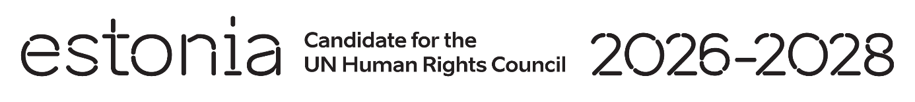

**Universal Periodic Review of the Eritrea**

**6 May 2024**

**Intervention by the delegation of Estonia**

Estonia welcomes the delegation of the Eritrea to its fourth UPR and its engagement with the UPR process. We urge Eritrea to cooperate with the Special Rapporteur on Eritrea as well as with other human rights mechanisms and organizations.

We remain very concerned about the high prevalence of gender-based violence and the absence of a specific legal framework addressing the rights of women. The reports of harassment, arrest and detention of persons for merely expressing their opinion, including political figures, journalists and religious and community leaders, are alarming as well.

In line with the previous cycle, Estonia would like to recommend to Eritrea:

* end indefinite national service;
* adopt a comprehensive definition of discrimination against women in line with Article 1 of the of the Convention on the Elimination of All Forms of Discrimination against Women, and repeal all discriminatory provisions of customary and religious laws;
* adopt legislation criminalizing all forms of physical, psychological, economic and sexual violence against women, including marital rape;
* review and amend the legislation on freedom of opinion and expression to enusre it is in compliance with the the International Covenant on Civil and Political Rights;
* ratify the Second Optional Protocol to the International Covenant on Civil and Political Rights, aiming at the abolition of the death penalty.
* grant access and cooperate fully with the Special Rapporteur on the situation of human rights in Eritrea.

Estonia wishes to the delegation of the Eritrea a successful review.

Thank you!