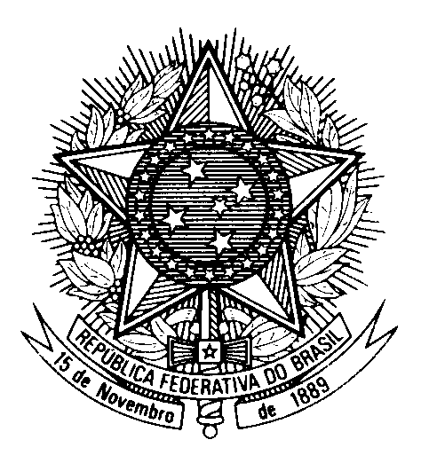
HRC UNIVERSAL PERIODIC REVIEW
ERITREA

(Geneva, May 6th 2024)

STATEMENT OF BRAZIL

Mister President,

Brazil welcomes the delegation of Eritrea.

We congratulate the country on the improvements in its health care facilities and in the provision of health care services, particularly in rural areas.

In a constructive spirit, Brazil recommends that Eritrea:

1) Ratify the Optional Protocol to the Convention against Torture and Other Cruel, Inhuman or Degrading Treatment or Punishment and the Optional Protocol to the International Covenant on Civil and Political Rights;

2) implement public policies towards protecting the rights of women and girls, combatting gender-based violence, ending female genital mutilation, and expanding access to education to women and girls at all levels of schooling.

We encourage Eritrea to engage and cooperate with the OHCHR and international human rights mechanisms.

We also encourage the country to ratify the International Convention on Enforced Disappearance.

Thank you.

