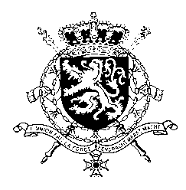
Représentation permanente de la Belgique auprès des Nations Unies et auprès des institutions spécialisées à Genève

WG UPR 46 – Eritrea
Intervention belge
6 Mai 2024

President,
Belgium welcomes the positive steps taken by the country in relation to women's rights, access to health and education. However, we regret the lack of cooperation with the UN Special Rapporteur on Eritrea and call on the authorities to engage constructively with all UN and regional human rights mechanisms, especially as Eritrea is currently member of the Human Rights Council.
We recommend the government of Eritrea to:
R1. Ensure that journalists and human rights defenders can exercise their right to freedom of expression, association and assembly without intimidation, threats, violence, and discrimination.
R2. Release or bring before a court all persons detained without a charge, respect international standards in the treatment of detainees, ensure there is no arbitrary arrest and incommunicado detention.
R3. Tackle impunity for past and on­going human rights violations and abuses and ensure access to independent and qualified justice and due process rights to all.
Thank you.

