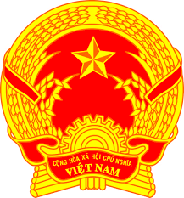
Statement of the Socialist Republic of Viet Nam
46th Session of the UPR Working Group
Review of the Dominican Republic
(Geneva, 07 May 2024)

Mister President,
Viet Nam extends a warm welcome to the delegation of the Dominican Republic.
We commend the Dominican Republic’s commitment to promote human rights through the extension of its National Human Rights Action Plan to cover 2023-2024 period as well as its efforts to integrate Sustainable Development Goals in the plan.
In a spirit of constructive dialogue, Viet Nam makes two recommendations to the Dominican Republic:
First, continue to encourage sustainable development and reduce poverty, particularly for people living in rural areas.
Second, continue its efforts to promote access to education, particularly primary and secondary education for children.
Viet Nam wishes the Dominican Republic every success with this UPR cycle and all efforts to realize human rights for its people.
Thank you, Mister President./.

Word count: 127 (1 min 03 sec/1 min 20 sec)

