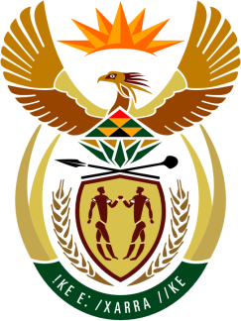

**SOUTH AFRICAN PERMANENT MISSION**

**TO THE UNITED NATIONS**

**AND OTHER INTERNATIONAL ORGANISATIONS**

**46th SESSION OF THE WORKING GROUP ON THE**

**UNIVERSAL PERIODIC REVIEW**

**Review of THE DOMINICAN REPUBLIC**

**2 MAY 2024**

**(1 MIN 20 Sec)**

**speaker no: 19**

***Check against delivery***

Mr. President,

South Africa welcomes the distinguished delegation of the Dominican Republic to this UPR Session and thanks it for the presentation of its national report.

My delegation recognises the Dominican Republic’s commitment and efforts to promoting and protecting human rights including through reopening, in 2023, the police force’s school of human rights.

South Africa wishes to respectfully recommend that the Dominican Republic:

1. Align the minimum age of employment with the end of compulsory education,
2. Enhance complaint mechanisms, and care and protection for victims of gender-based violence,
3. Redouble awareness-raising and dissemination efforts in relation to human rights, including regarding the prevention of discrimination, violence and hate speech, and the protection of vulnerable groups,
4. Consider increasing investment in maternal and neonatal healthcare and undertake further efforts to reduce infant and child mortality.

South Africa wishes the Dominican Republic a successful review.

I thank you.