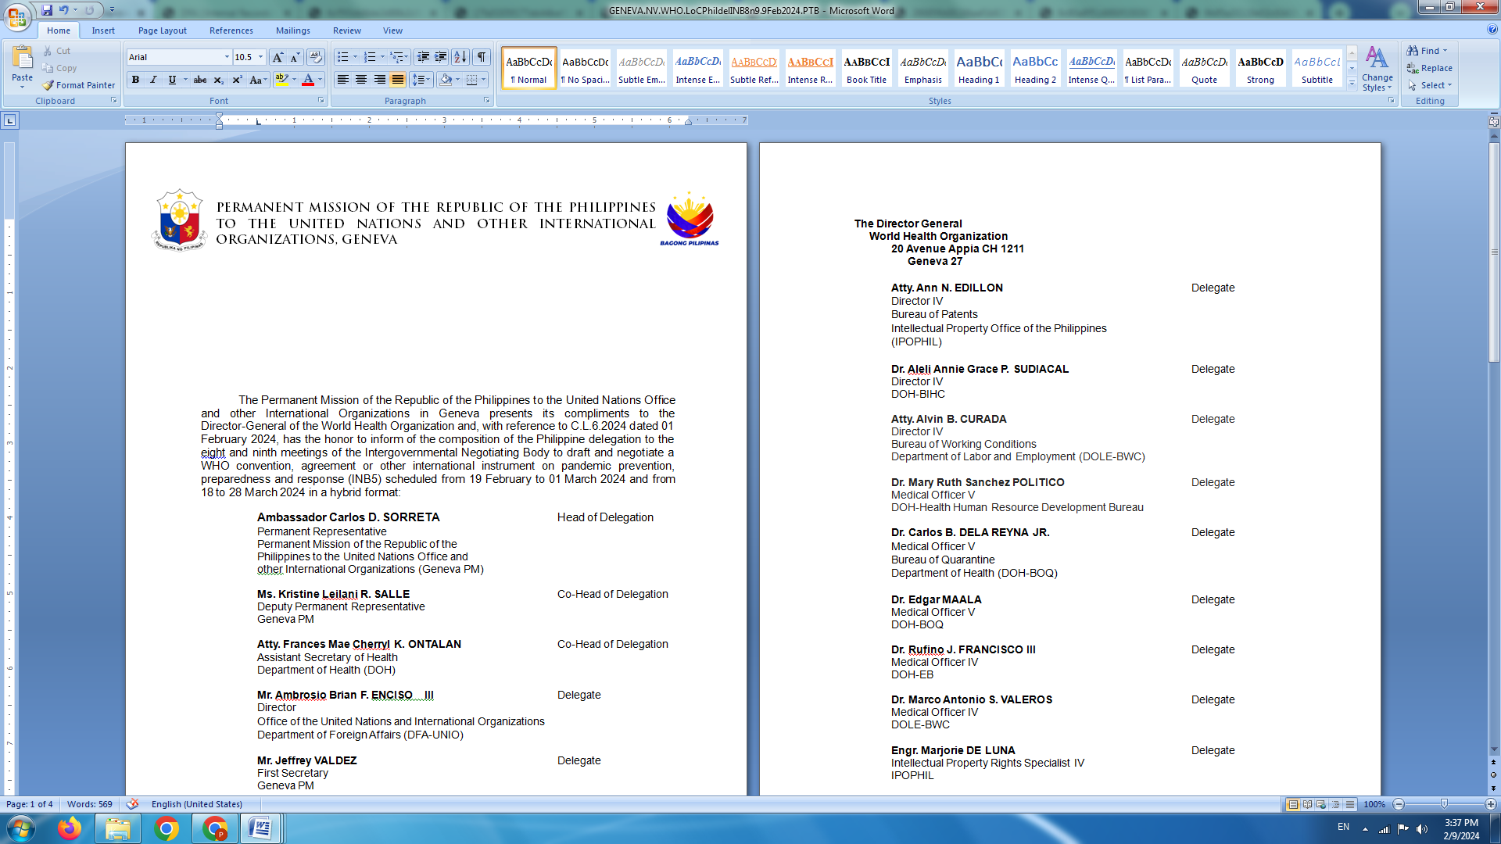

**P H I L I P P I N E S**

**HUMAN RIGHTS COUNCIL**

**46th Session of the Working Group on the Universal Periodic Review**

07 May 2024, Palais des Nations, Geneva, Switzerland

**UNIVERSAL PERIODIC REVIEW OF THE DOMINICAN REPUBLIC**

*To be delivered by:*

**LUNINGNING CAMOYING VALDEZ**

**First Secretary**

*Speaking time: 1 minute 20 seconds*

The Philippines warmly welcomes the delegation of the Dominican Republic.

We welcome the positive steps taken to further develop the country’s policy and institutional frameworks on human rights promotion and protection. These include the decision to mainstream human rights in development plans and actions with the adoption of the National Development Strategy 2030.

We also acknowledge the reforms in law enforcement to curb police violence and continuing efforts to promote good governance in order to root out corruption and improve the administration of justice.

In a constructive spirit, we recommend the following:

1. Step up efforts in combatting gender-based discrimination and violence, including by effectively implementing the National Gender Equity and Equality Plan 2020-2030 and expediting the adoption of a comprehensive law on violence against women and children;
2. Increase investment in health services to further reduce maternal and neonatal mortality; and
3. Further strengthen domestic law and enforcement mechanisms for the prevention and prosecution of cases of child labor and trafficking of children for commercial sexual exploitation.

We wish the Dominican Republic all success in this review cycle. **END**