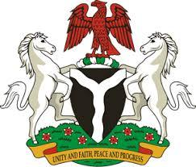

*Please check against delivery*

**HUMAN RIGHTS COUNCIL**

**46TH SESSION OF THE WORKING GROUP OF THE UPR**

**REVIEW OF THE DOMINICAN REPUBLIC**

**7TH MAY, 2024**

**STATEMENT BY NIGERIA**

**Mr. President,**

Nigeria welcomes the delegation of Dominican Republic to the presentation of its National Report for the Fourth UPR Cycle and commends the Government for its commitment to international human rights obligations and human rights mechanisms.

2. Nigeria further commends the Dominican Republic for establishing an independent public prosecution office to combat corruption. We further applaud its efforts to improve access to justice, through the creation of specialized courts to address cases of corruption and violence against women.

3. In the spirit of constructive dialogue, Nigeria wishes to recommend to the Dominican Republic as follows:

1. To consider further necessary measures to ensure the protection of the rights of migrants, including through the ratification of the Convention on the Protection of the Rights of all Migrant Workers and Members of their Families; and
2. To intensify efforts to ensure the full enjoyment of human rights by people of African Descent.

4. We wish the Dominican Republic a very successful review process.

I thank you, Mr. President.