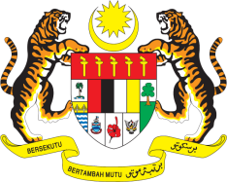

**STATEMENT BY MALAYSIA**

**REVIEW OF DOMINICAN REPUBLIC**

**46TH SESSION OF THE UPR WORKING GROUP**

**29 APRIL – 10 MAY 2024**

Malaysia thanks Dominican Republic for the presentation of its national report.

1. Malaysia commends the Dominican Republic for its effective use of online tools ad systems to facilitate coordination, follow-up and implementation of its UPR recommendations, alongside SDGs, showcasing the country’s commitment in leveraging technology to enhance human rights governance.
2. In the spirit of constructive engagement, Malaysia recommends the following:
   1. First, increase access to education for children in remote areas through the provision of improved learning facilities.
   2. Second, enhance access to healthcare for all especially disadvantaged communities by providing quality maternal health care for women and improving health insurance coverage for workers in vulnerable sectors.
   3. Third, strengthen efforts to improve the socio-economic conditions of persons with disabilities by enhancing public sector support and raising community awareness through targeted capacity-building programmes and inclusive education policies.
3. We wish the Dominican Republic a successful review.

Thank you.

**7 MAY 2024**

**GENEVA**