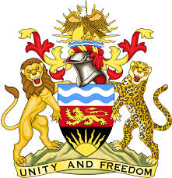

**REPUBLIC OF MALAWI**

**MALAWI STATEMENT ON DOMINICAN REPUBLIC UNIVERSAL PERIODIC REVIEW**

**TUESDAY, 7TH MAY 2024**

**Mr. President**,

Malawi welcomes the Dominican Republic to this review and thanks the delegation for the comprehensive presentation.

In the spirit of constructive dialogue, Malawi makes the following recommendations to the Dominican Republic:

1. Consider ratifying the Convention relating to the Status of Stateless Persons and the Convention on the Reduction of Statelessness.
2. Continue efforts to bring the child justice system into line with the Convention on the Rights of the Child.
3. Intensify efforts aimed at promoting gender equality.

We wish Dominican Republic all the best at this review and in the implementation of the recommendations.

**Thank you, Mr. President**.