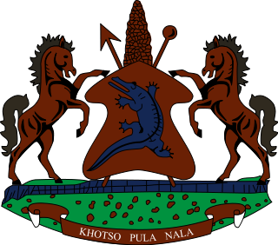

**INTERVENTION OF THE DELEGATION OF LESOTHO UNDER THE UPR REVIEW OF DOMINICAN REPUBLIC**

**07 MAY 2024**

**GENEVA, SWITZERLAND**

**Thank you Mr. President,**

We welcome the delegation of the Dominican Republic to the UPR Working Group and thank them for their comprehensive Report and presentation. We commend them for the positive developments achieved since their last review, notably in strengthening public policies to address discrimination and social challenges, including through the adoption of policies and programmes designed to contribute to and foster progress towards equity and social inclusion for all.

Lesotho seizes this opportunity to offer the following reccomendaions to the Government of the Dominican Republic; 1. To continue efforts to ensure that perpetrators of sexual violence against women and girls are punished and, 2. to increase efforts to prosecute human trafficking offenses and seek appropriate penalties for convicted traffickers, which should include lengthy prison sentences and heavy fines and lastly, to undertake measures to curb overcrowding in detention centers by offering alternative sentences for minor offences.

Finally, Lesotho wishes the government of the Dominican Republic every success with this UPR Cycle

**THANK YOU**