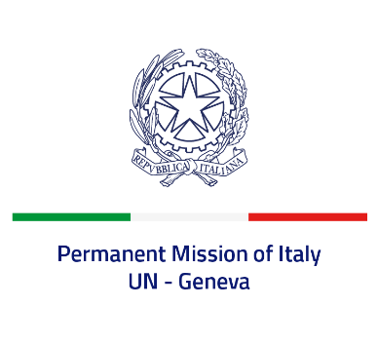

*Check against delivery*

**UPR 46 – Dominican Republic**

**Tuesday 7 May 2024, 14:30 – 18:00**

**Delivered by: Permanent Representative of Italy Amb. Vincenzo Grassi**

Thank you, Mister President.

We thank the distinguished delegation of the Dominican Republic for their national report and presentation.

Italy appreciates the commitment of the Dominican Republic to the UPR and welcomes efforts to improve the protection of human rights at national level, including with regard to women’s rights and gender-based violence, as well as the fight against corruption. We also welcome the recent legislation prohibiting marriage for persons under the age of 18.

Italy would like to recommend to:

* *Continue efforts in promoting gender equality and protecting women’s rights, including against domestic and gender-based violence.*
* *Combat prisons’ overcrowding and ensure decent living conditions for both local and foreign detainees.*
* *Maximize efforts to tackle the issue of statelessness.*

We wish the delegation of the Dominican Republic a successful review.

I thank you.