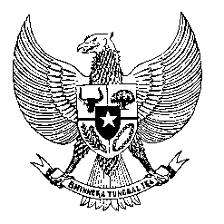

Permanent Mission

of the Republic of Indonesia to the UN, WTO,

and Other International Organizations

in Geneva

**STATEMENT BY THE DELEGATION OF THE REPUBLIC OF INDONESIA**

**AT THE 46th SESSION OF THE UPR WORKING GROUP**

**CONSIDERATION OF THE UPR REPORT OF DOMINICAN REPUBLIC**

**7 MAY 2024**

**Mr. Vice-President**

* We welcome the esteemed delegation of the Dominican Republic and thank them for presenting the report.
* We commend the development made by the Dominican Republic since the last UPR towards full realization of human rights for its people.
* We especially highlight the adoption of the 2020 Strategic Plan for a Violence-Free Life for Women, which is in line with our past recommendation on preventing violence against women.
* In a constructive spirit, Indonesia further recommends that the Dominican Republic:
  1. Consider to ratify the International Convention on the Protection of the Rights of All Migrant Workers and Members of Their Families.
  2. Continue efforts to strengthen the institutional capacity and competence of the Ombudsman’s Office for accreditation by the GANHRI.
  3. Expedite the process to establish a comprehensive law on violence against women.
* Finally, we wish the Dominican Republic every success in its UPR process.
* Thank you.

***Word counts: 146.***

***Time limit: 1 minute 20 seconds.***