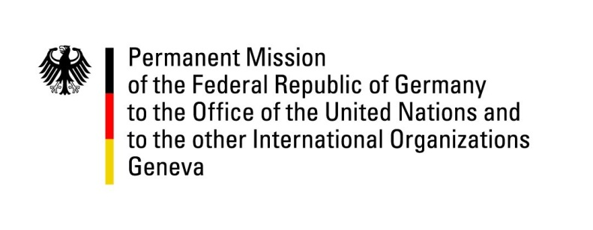

**United Nations Human Rights Council**

**46th Session of the UPR Working Group**

**Geneva, 7th of May 2023**

**German Recommendations to**

**Dominican Republic**

Mister President,

Germany welcomes the delegation of the Dominican Republic.

Germany commends the Dominican Republic for its efforts to improve the human rights situation, including the adoption of law 1-21 banning child marriages, and more specifically marriages of persons under 18 years of age, in January 2021.

However, Germany remains concerned by prevalent sexual and gender-based violence, discrimination against refugees especially from neighboring Haiti, and remaining challenges concerning the rule of law, including conditions in prisons.

Germany therefore recommends to:

* initiate concrete actions in order to reduce teenage pregnancies and strengthen the sexual and reproductive rights of girls and young women;
* take measures in order to shorten overly long pre-trial detention and improve the human rights situation of detainees;
* guarantee the human and procedural rights of migrants (including Haitians) during the process of deportation or repatriation.

Thank you, Mister President.