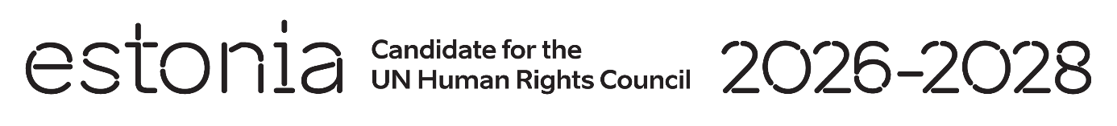

**Universal Periodic Review of the Dominican Republic**

**7 May 2024**

**Intervention by the delegation of Estonia**

Estonia welcomes the delegation of the Dominican Republic to its fourth UPR and thanks the delegation for the presentation of its national report. We would like to commend the Dominican Republic’s active and constructive role as a member in the Human Rights Council.

Estonia acknowledges advances made to strengthen freedom of opinion and expression and the protection of journalists and media workers. We welcome the National Gender Equity and Equality Plan 2020–2030.

We are concerned about the high maternal mortality rate and we urge the Government to increase investment in maternal and neonatal health care.

We would like to recommend to:

* amend the Criminal Code to legalize abortion, at least in cases of rape, incest, threats to the life and/or health, and decriminalize it in all other cases;
* adopt a comprehensive law on gender-based violence against women;
* adopt a comprehensive sexual and reproductive health policy for adolescents, including developing the national plan for inclusion of comprehensive sexuality education in school curricula;
* decriminalize defamation and incorporate it into the Civil Code in accordance with international standards.

Estonia wishes to the Dominican Republic a successful review.

Thank you.