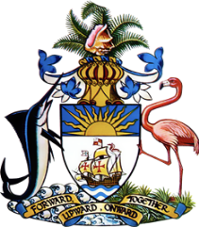

**Statement by  
 Permanent Mission of The Bahamas to the United Nations Office and other International Organizations in Geneva**

**at the 46th Session of the Universal Periodic Review Working Group**

***Presentation of UPR Report by the Dominican Republic 7* May 2024**

Thank you, Mr. President,

The Bahamas thanks the Dominican Republic for its detailed report and appreciates the significant advancements made since the last review.

We commend the Dominican Republic for its assertive and ongoing commitment to enhancing social policies aimed at protecting vulnerable populations, particularly its remarkable efforts in child protection. The substantial increase in the budget allocation for the National Council for Children and Adolescents by 87.2 percent has enabled critical strategies and initiatives that significantly benefit vulnerable children. Additionally, commendable are the Dominican Republic's efforts to combat violence against women, notably through initiatives such as the "Violence-Free Life for Women," part of a national policy designed to address the root causes of violence against women and girls.

In a spirit of constructive dialogue, The Bahamas recommends that the Dominican Republic:

1. Continue to expand its successful programs for the protection and integration of children and adolescents, emphasising preventative measures and support systems that ensure their safety and development in all societal aspects.
2. Build on its educational reforms by enhancing access and quality of education for all children, with special emphasis on reducing disparities for marginalised communities, ensuring that every child can benefit from educational advancements post-pandemic.
3. Intensify efforts to incorporate climate resilience into development policies, focusing on sustainable practices that address both current environmental challenges and the future impacts of climate change.

We extend our best wishes to the Dominican Republic for a successful review.

I thank you.